Algebra 1: Unit 4, Lesson 6

- What is the value of $f(5)$, when $f\left(x\right)=2x-12$?
$f\left(5\right)= ______________$

-2

- Nelson’s birthday party will be at the skating rink. The cost for each person is $20. The cost of the room for the party is $80. The function $C(x)=20x+80$ models the total cost, C, with $x$ people at the party.
What is the maximum number of people who can be at the party without exceeding the budget of $400?
16

- The graph of a $f(x)$ is shown.
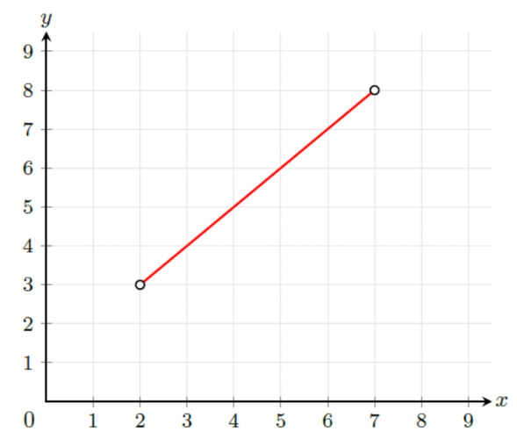
What is the domain of $f(x)$?
2 < x < 7

